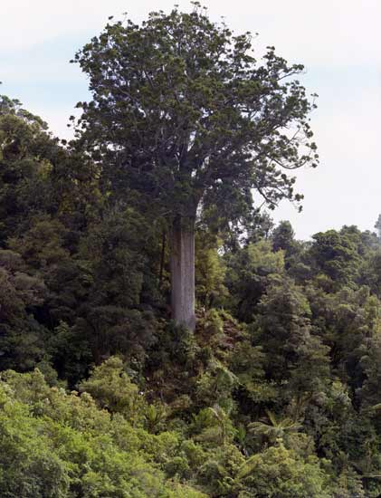

When fully grown, the kauri tree has a massive columnar trunk topped by branches that spread like umbrella spokes, supporting a crown of leaves.

Joanna Orwin, 'Kauri forest - How and where kauri grows', Te Ara - the Encyclopedia of New Zealand, http://www.TeAra.govt.nz/en/photograph/10018/the-kauri-tree (accessed 15 August 2021)

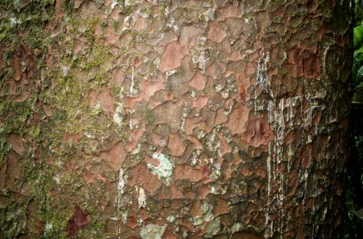

Greyish-brown kauri bark has a hammer-mark texture. A mature tree continuously sheds its outer bark in large scales to prevent climbing or perching plants from gaining a permanent hold. Kauri gum is oozing from the horizontal cracks in this bark – it is the tree’s way of sealing damaged surfaces.

Joanna Orwin, 'Kauri forest - How and where kauri grows', Te Ara - the Encyclopedia of New Zealand, http://www.TeAra.govt.nz/en/photograph/10019/bark-and-gum (accessed 15 August 2021)

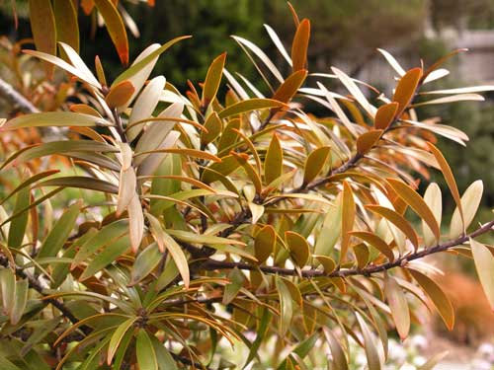

Kauri leaves are flat, oblong and leathery. Bronze when young, they turn bright green as the tree matures.

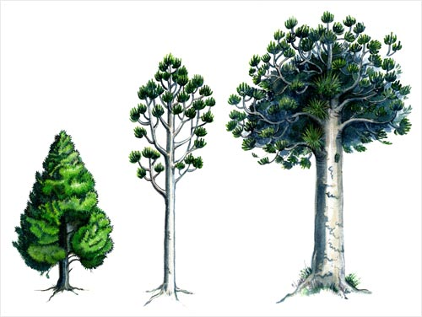

A kauri tree takes on different forms as it grows and matures. This diagram shows three of the most important stages, from adolescent to mature tree.

While young (left), the kauri has a typical conifer form with a tapering trunk, spiralling whorls of short branches, and a narrow, triangular crown.

Between 30 and 50 years, the tree begins to shed its lower branches (centre). At this stage it is called a ‘ricker’, after its use in the 19th century for naval masts and spars.

Once the tree has emerged above the canopy of the forest in its mature stage, the girth of its trunk increases and its top branches support a spreading crown of leaves (right).

Joanna Orwin, 'Kauri forest - How and where kauri grows', Te Ara - the Encyclopedia of New Zealand, http://www.TeAra.govt.nz/en/photograph/10018/the-kauri-tree (accessed 15 August 2021)

Beets, P. N., Kimberley, M. O., Oliver, G. R., Pearce, S. H., Graham, J. D., & Brandon, A. (2012). Allometric Equations for Estimating Carbon Stocks in Natural Forest in New Zealand. *Forests*, *3*(3), 818–839. doi:10.3390/f3030818